3.1 Setup or Configure REST Assured



This section will guide you to :

* Setup or configure REST Assured

**Development Environment:**

* Java 1.8
* Eclipse
* TestNG
* Maven

This guide has three subsections, namely:

3.1.1 Creating a Maven project in Eclipse

3.1.2 Updating the pom.xml file with the latest stable REST Assured dependencies

3.1.3 Pushing the code to GitHub repositories

**Step 3.1.1:** Creating a Maven project in Eclipse

REST Assured is an API designed for automating REST services or REST APIs.

* Open Eclipse.
* Click on File---> click on New--->Project.
* Select the Maven project and click on Next.

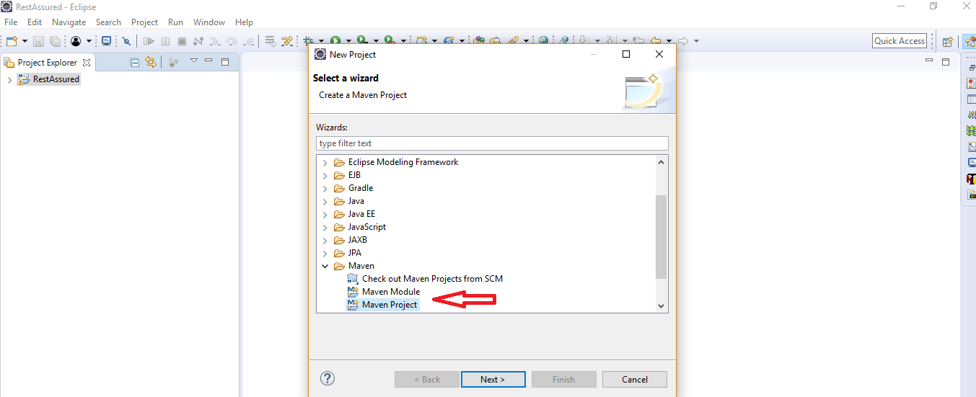

* Enter the Group id, Artifact id, and click on Finish.

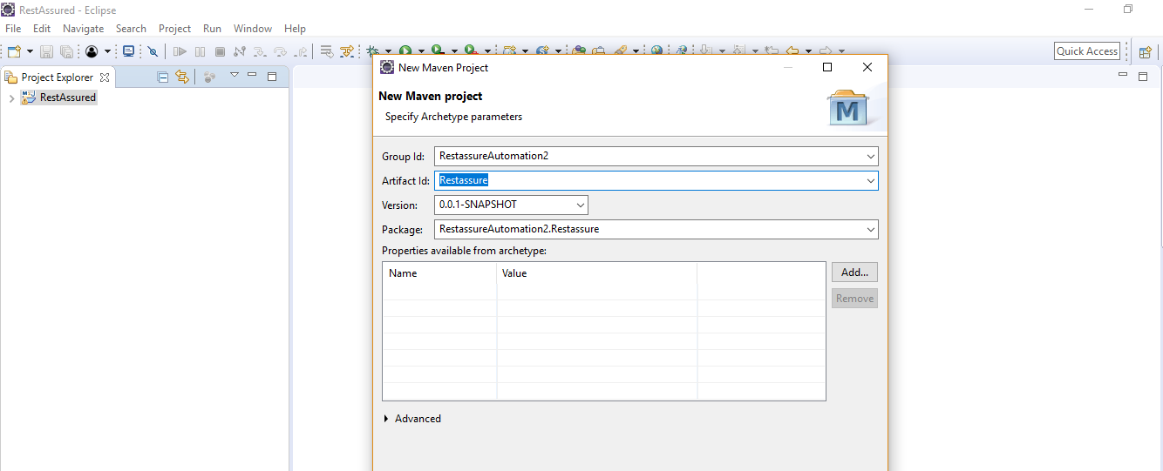

* Right click on Project---> src/test/java---> Package.
* Enter the package name and click on Finish.

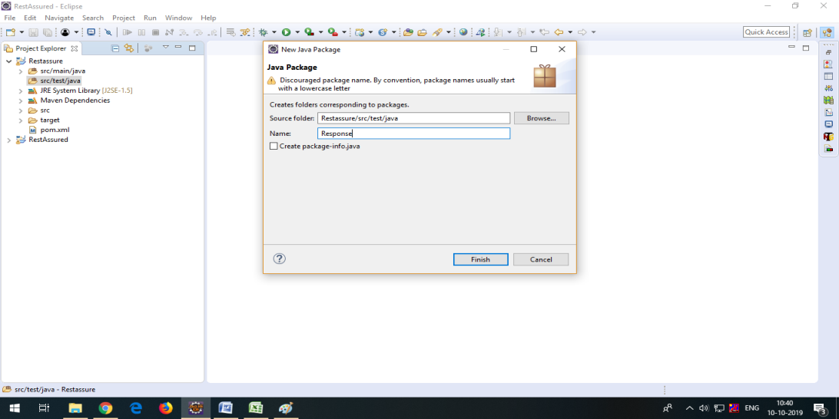

* Right click on Package---> New---> Class.
* Enter the class name and click on Finish.

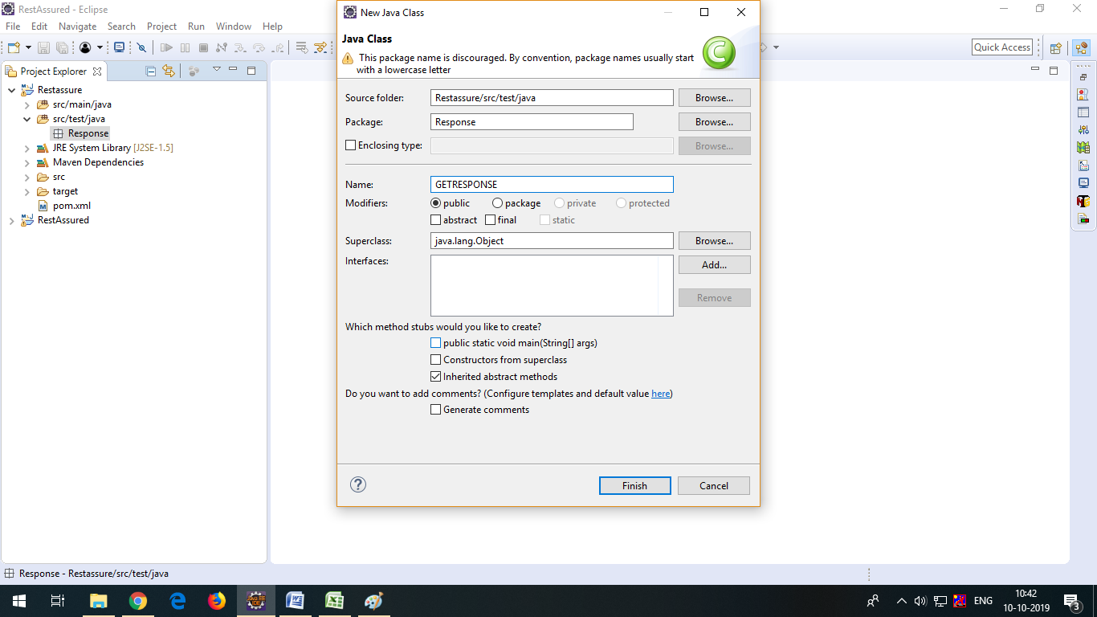

**Step 3.1.2:** Updating the pom.xml file with the latest stable REST Assured dependencies

* Open the pom.xml file.

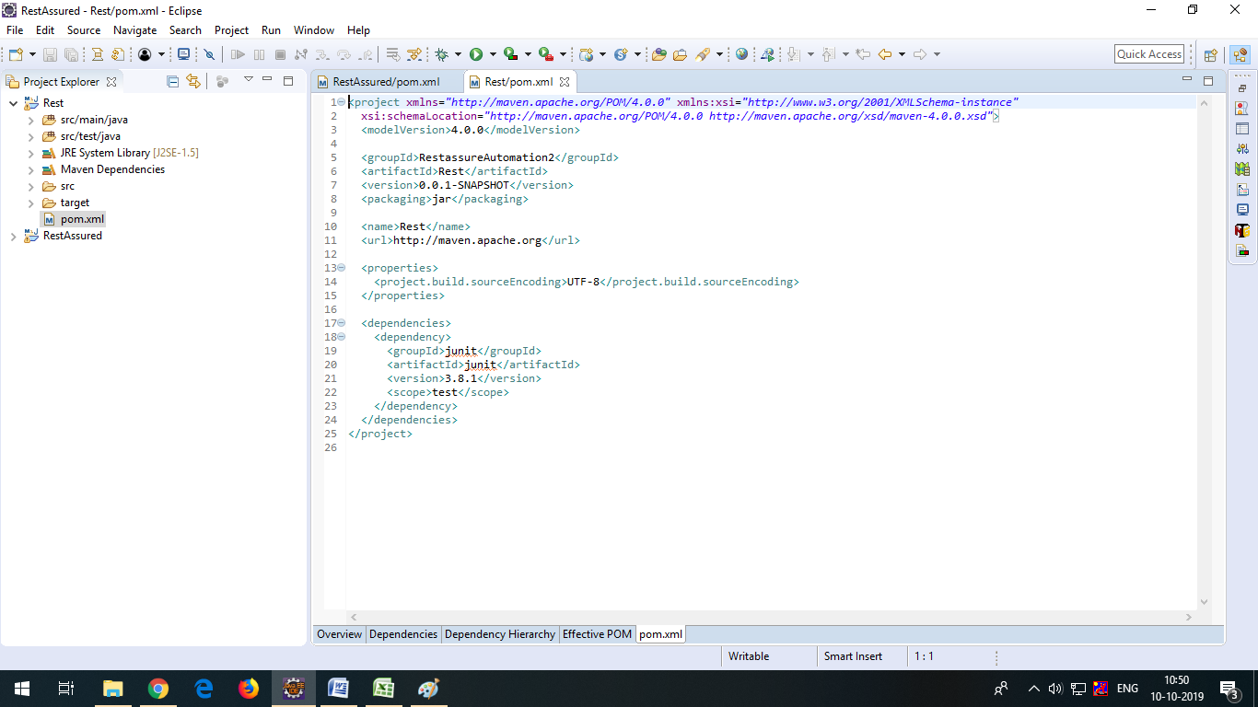

* Go to a browser and search for Maven repository.

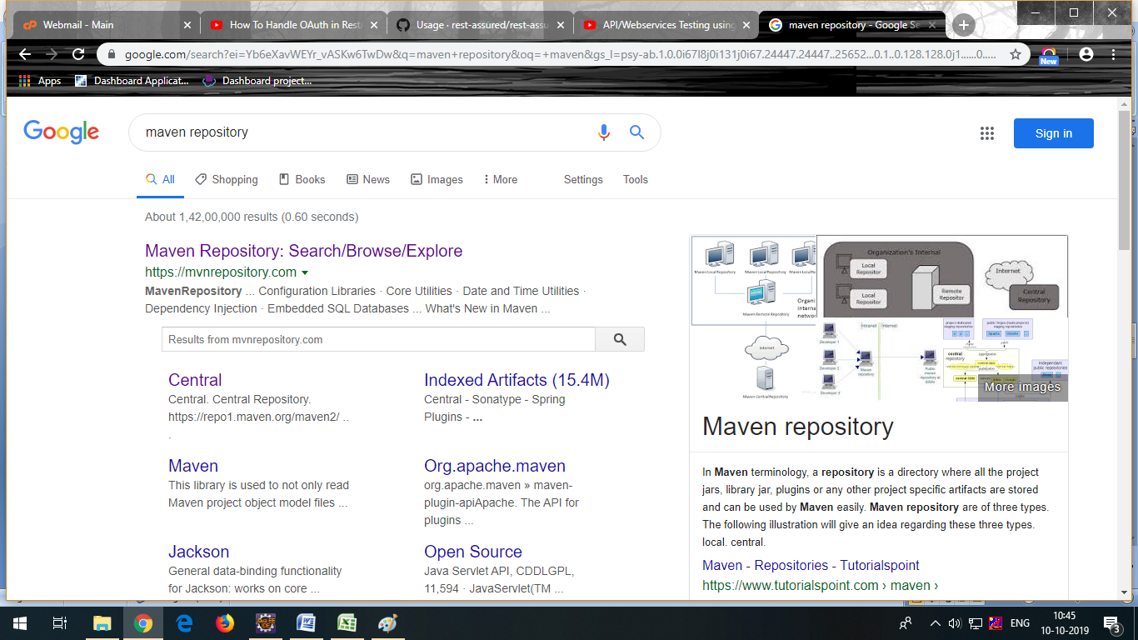

* Add the dependencies to the pom.xml file, after adding all the dependencies the pom.xml file will look like this:

<dependencies>

<!-- https://mvnrepository.com/artifact/io.rest-assured/rest-assured -->

<dependency>

<groupId>io.rest-assured</groupId>

<artifactId>rest-assured</artifactId>

<version>3.3.0</version>

<scope>test</scope>

</dependency>

<!-- https://mvnrepository.com/artifact/org.testng/testng -->

<dependency>

<groupId>org.testng</groupId>

<artifactId>testng</artifactId>

<version>6.14.3</version>

<scope>test</scope>

</dependency>

<!-- https://mvnrepository.com/artifact/com.googlecode.json-simple/json-simple -->

<dependency>

<groupId>com.googlecode.json-simple</groupId>

<artifactId>json-simple</artifactId>

<version>1.1.1</version>

</dependency>

<!-- https://mvnrepository.com/artifact/org.apache.poi/poi -->

<dependency>

<groupId>org.apache.poi</groupId>

<artifactId>poi</artifactId>

<version>4.1.0</version>

</dependency>

<!-- https://mvnrepository.com/artifact/org.apache.poi/poi-ooxml -->

<dependency>

<groupId>org.apache.poi</groupId>

<artifactId>poi-ooxml</artifactId>

<version>4.1.0</version>

</dependency>

<!-- https://mvnrepository.com/artifact/io.cucumber/cucumber-java -->

<dependency>

<groupId>io.cucumber</groupId>

<artifactId>cucumber-java</artifactId>

<version>2.0.0</version>

</dependency>

<!-- https://mvnrepository.com/artifact/io.cucumber/cucumber-junit -->

<dependency>

<groupId>io.cucumber</groupId>

<artifactId>cucumber-junit</artifactId>

<version>2.0.0</version>

<scope>test</scope>

</dependency>

<!-- https://mvnrepository.com/artifact/info.cukes/gherkin -->

<dependency>

<groupId>info.cukes</groupId>

<artifactId>gherkin</artifactId>

<version>2.12.2</version>

<scope>provided</scope>

</dependency>

<!-- https://mvnrepository.com/artifact/info.cukes/cucumber-jvm-deps -->

<dependency>

<groupId>info.cukes</groupId>

<artifactId>cucumber-jvm-deps</artifactId>

<version>1.0.5</version>

<scope>provided</scope>

</dependency>

<!-- https://mvnrepository.com/artifact/io.cucumber/cucumber-jvm -->

<dependency>

<groupId>io.cucumber</groupId>

<artifactId>cucumber-jvm</artifactId>

<version>2.0.0</version>

<type>pom</type>

</dependency>

<!-- https://mvnrepository.com/artifact/net.masterthought/cucumber-reporting -->

<dependency>

<groupId>net.masterthought</groupId>

<artifactId>cucumber-reporting</artifactId>

<version>1.0.0</version>

</dependency>

<!-- https://mvnrepository.com/artifact/org.seleniumhq.selenium/selenium-java -->

<dependency>

<groupId>org.seleniumhq.selenium</groupId>

<artifactId>selenium-java</artifactId>

<version>3.5.3</version>

</dependency><!-- https://mvnrepository.com/artifact/junit/junit -->

<dependency>

<groupId>junit</groupId>

<artifactId>junit</artifactId>

<version>3.8.1</version>

<scope>test</scope>

</dependency>

<!-- https://mvnrepository.com/artifact/org.apache.logging.log4j/log4j-core -->

<dependency>

<groupId>org.apache.logging.log4j</groupId>

<artifactId>log4j-core</artifactId>

<version>2.12.1</version>

</dependency>

<!-- https://mvnrepository.com/artifact/io.rest-assured/json-schema-validator -->

<dependency>

<groupId>io.rest-assured</groupId>

<artifactId>json-schema-validator</artifactId>

<version>4.1.2</version>

</dependency>

<!-- https://mvnrepository.com/artifact/io.rest-assured/json-path -->

<dependency>

<groupId>io.rest-assured</groupId>

<artifactId>json-path</artifactId>

<version>4.1.1</version>

</dependency>

<!-- https://mvnrepository.com/artifact/org.hamcrest/java-hamcrest -->

<dependency>

<groupId>org.hamcrest</groupId>

<artifactId>java-hamcrest</artifactId>

<version>2.0.0.0</version>

<scope>test</scope>

</dependency>

<!-- https://mvnrepository.com/artifact/org.hamcrest/hamcrest-core -->

<dependency>

<groupId>org.hamcrest</groupId>

<artifactId>hamcrest-core</artifactId>

<version>2.2-rc1</version>

<scope>test</scope>

</dependency>

<!-- https://mvnrepository.com/artifact/org.hamcrest/hamcrest-library -->

<dependency>

<groupId>org.hamcrest</groupId>

<artifactId>hamcrest-library</artifactId>

<version>2.2-rc1</version>

<scope>test</scope>

</dependency>

<dependency>

<groupId>org.codehaus.groovy</groupId>

<artifactId>groovy-all</artifactId>

<version>2.4.5</version>

</dependency>

<!-- https://mvnrepository.com/artifact/io.rest-assured/xml-path -->

<dependency>

<groupId>io.rest-assured</groupId>

<artifactId>xml-path</artifactId>

<version>3.0.0</version>

</dependency>

</dependencies>

* Click on Save.

**Step 3.3.3**: Pushing the code to GitHub repositories

Open your command prompt and navigate to the folder where you have created your files.

cd <folder path>

Initialize your repository using the following command:

git init

Add all the files to your git repository using the following command:

git add . 

Commit the changes using the following command:

git commit . -m “Changes have been committed.”

Push the files to the folder you initially created using the following command:

git push -u origin master